CS 255 Project Two

UML Diagrams

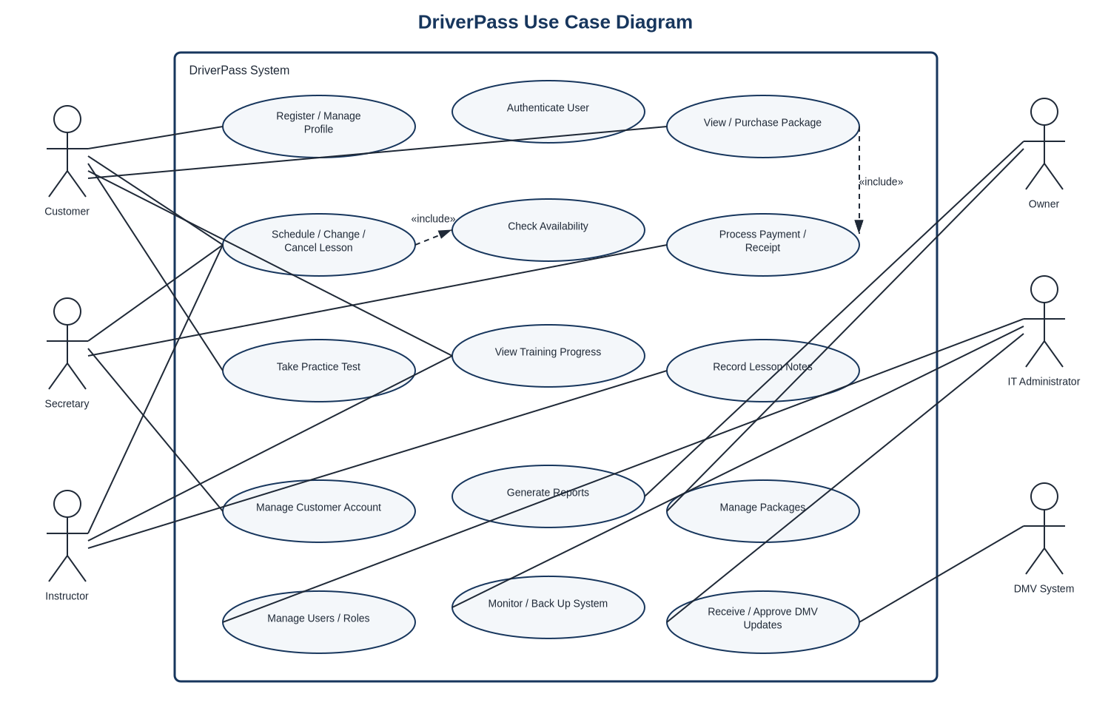
Figure 1. DriverPass use case diagram
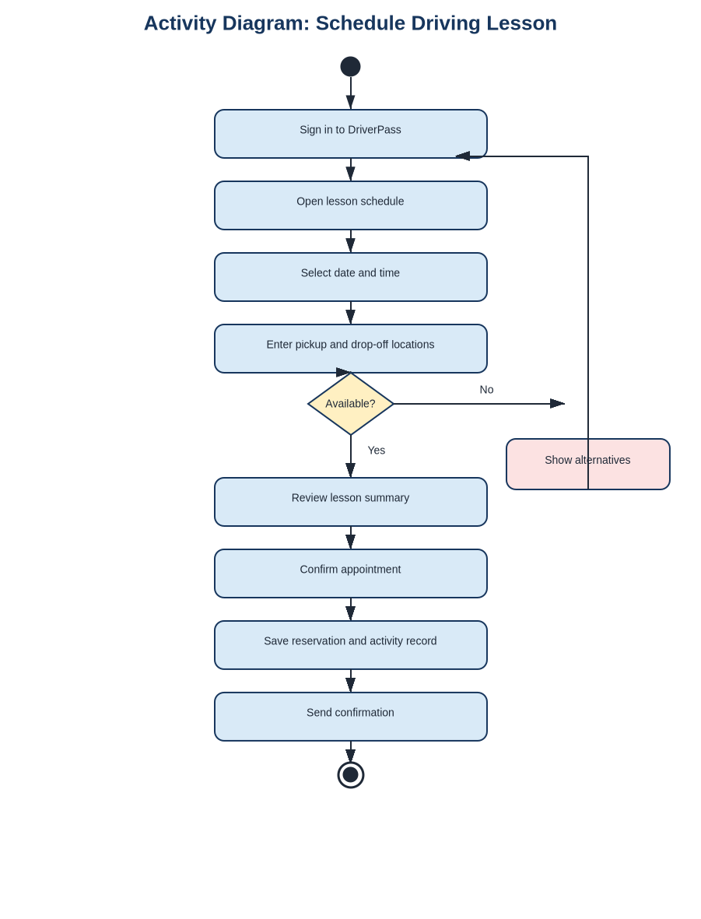
Figure 2. Schedule driving lesson activity diagram
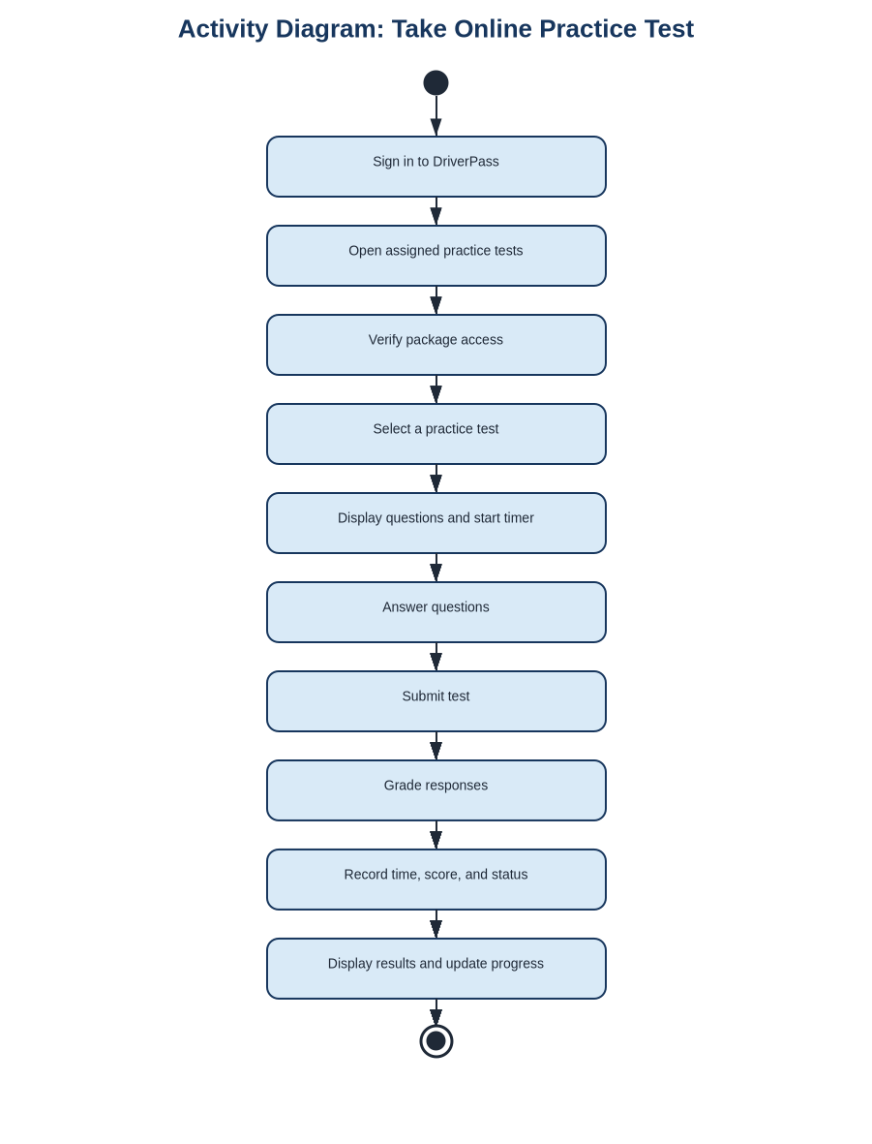
Figure 3. Take online practice test activity diagram

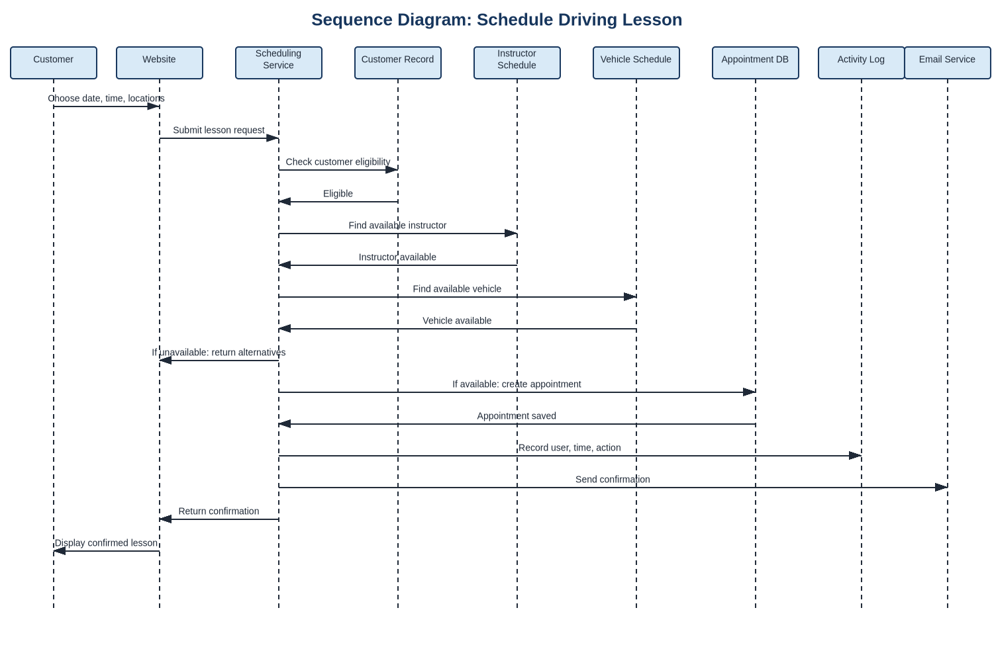
Figure 4. Scheduling sequence diagram
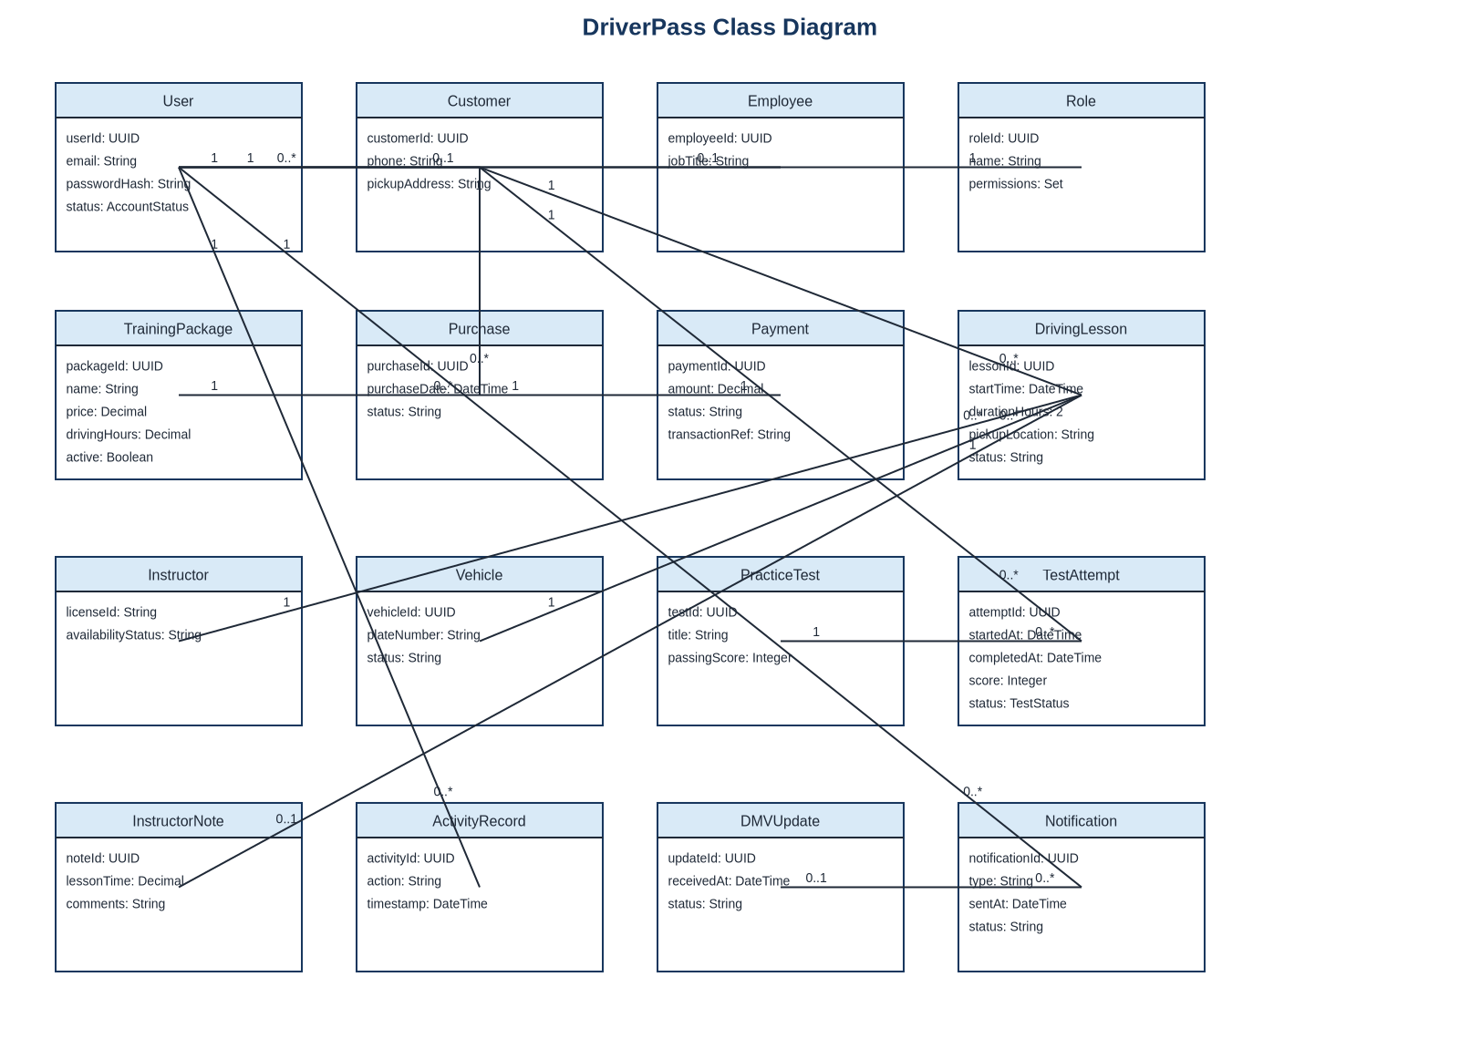
Figure 5. DriverPass class diagram

Technical Requirements

Hardware
DriverPass will not need to maintain an on-site application server. Customers and employees need an internet-connected computer, tablet, or smartphone capable of running a current web browser. DriverPass offices should use business-grade network equipment, protected Wi-Fi, and managed employee devices. The cloud provider supplies the server, storage, backup, and recovery hardware. This approach supports the initial ten-vehicle operation while allowing capacity to grow without replacing local equipment.

Software
The proposed system is a responsive web application with separate interface, application-service, and data layers. A relational database will store accounts, roles, packages, purchases, payments, lessons, instructor and vehicle availability, practice tests, attempts, notes, notifications, and activity records. Supporting services include email delivery, a payment processor, and an adapter for the DMV information source. Current versions of Chrome, Edge, Firefox, and Safari on Windows, macOS, Android, and iOS should be supported.

Development and Testing Tools
The team should use Lucidchart for UML models, a version-control repository for source code and design history, an integrated development environment, database migration tools, automated unit and integration tests, browser and mobile-layout testing, security scanning, and issue tracking. Separate development, test, and production environments will allow changes to be verified before customers use them.

Cloud and Network Infrastructure
The application should be hosted in a monitored cloud environment with scalable computing, managed relational storage, encrypted connections, automated backups, recovery procedures, centralized logs, health alerts, and protection against common web attacks. Common pages should load within three seconds and valid appointment changes should complete within five seconds under normal conditions. The availability target is at least 99.5 percent, excluding announced maintenance.

Security and Data Protection
Every user must authenticate before viewing protected information. Permissions will be assigned by role so customers, instructors, the secretary, the owner, and the IT administrator see only the functions required for their responsibilities. Administrative accounts should use multifactor authentication. Passwords must be securely hashed; personal and payment-related information must be encrypted in transit and at rest. Accounts will be temporarily locked after five unsuccessful attempts within fifteen minutes, and reset links will be time-limited. A compliant external payment service will process cards, and DriverPass will not store card security codes.

Data Integrity, Integration, and Recovery
Database rules and transaction controls must prevent a customer, instructor, or vehicle from being placed in conflicting lessons. Each appointment change will record the responsible user, timestamp, and action. The DMV connection should isolate external format changes from the rest of the application, notify authorized staff of updates, and require review before revised content is published. Backups should be encrypted, monitored, and tested through scheduled recovery exercises. Records may be downloaded for review, but only online transactions may update the official system.

Accessibility, Maintenance, and Growth
The interface should use responsive layouts, keyboard navigation, readable contrast, descriptive labels, and meaningful text alternatives. Monitoring should alert the IT administrator to repeated login failures, unavailable services, unsuccessful DMV updates, and failed backups. Low-traffic maintenance windows should be announced in advance. The layered design and scalable cloud resources will allow DriverPass to add customers, employees, vehicles, lessons, courses, and tests without redesigning the entire system.

